TECHNICAL ARCHITECTURE BRIEF
Meta-Analysis 101 — AI-Assisted Workshop Design
How the Midterm and Final workshops use AI to guide learners through a complete meta-analysis — while keeping all R code deterministic and error-free.

1. Platform overview
Meta-Analysis 101 is a bilingual (Traditional Chinese / English) interactive educational platform that teaches systematic review and meta-analysis methodology to pharmacists and clinical researchers. The hands-on workshop is split into two phases:
Phase | Component | Steps | AI calls | Focus
Phase 1 | Midterm.jsx | 5 | 2 | Planning: PICO, search, studies, extraction, RoB
Phase 2 | Final.jsx | 5 | Up to 4 | Analysis: effect size, run (WebR), interpret, conclude

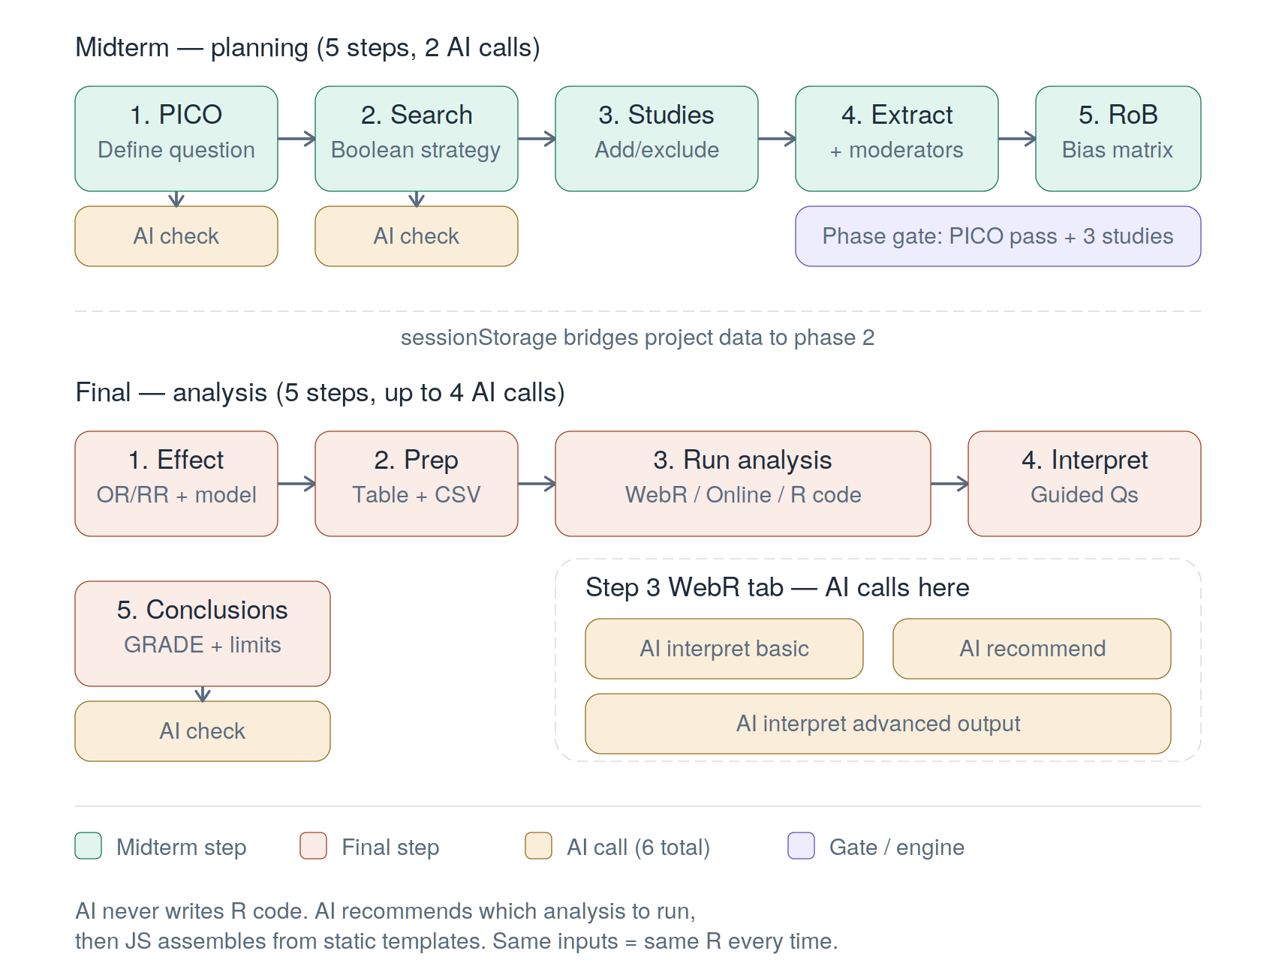
Figure 1 — Both workshop phases with all AI touchpoints and the session bridge between them.

2. Midterm workshop — planning phase
Step | What the user does | AI role
1. Define PICO | Enters clinical question + P/I/C/O fields | AI validates specificity, searchability, feasibility
2. Search strategy | Picks databases, writes Boolean query | AI checks syntax, coverage, MeSH terms
3. Add studies | Adds study cards with citation, design, N | None
4. Data extraction | Enters outcome data + moderator variables | None
5. Risk of bias | Fills traffic-light RoB matrix | None

Phase gate: PICO must pass AI check and at least 3 studies must be included before proceeding. Moderator columns (Step 4) let users tag studies with variables like region or dosage for subgroup analysis in Phase 2.

3. Final workshop — analysis phase
Step | What the user does | AI role
1. Effect + model | Chooses OR/RR/MD/SMD + fixed/random | None
2. Prepare data | Reviews table; downloads CSV | None
3. Run analysis | WebR in-browser / Online calc / R code | Up to 3 calls (Section 4)
4. Interpret | Answers guided questions | None
5. Conclusions | Finding, GRADE, limitations, implications | AI checks consistency

Step 3 is the technical core: the WebR tab runs real R (metafor package) in the browser via WebAssembly, producing genuine forest plots, funnel plots, and statistical output identical to desktop RStudio.

4. Step 3 WebR tab — the two-layer architecture
The differentiator: Other MA websites run static, pre-defined analyses. MA101 uses AI to judge which advanced analyses are appropriate for the user’s specific dataset, then assembles and executes the corresponding R code — all in-browser. The experience feels conversational and custom; the code is safe and deterministic.

Layer 1 — Basic analysis (no AI in code generation)
The user’s choices feed into buildRCode(), a pure JavaScript function that deterministically assembles R code. Same inputs = same R string every time. WebR executes it, producing forest plot, funnel plot, and stats (pooled effect, CI, I², Q, τ²). After results display, the user clicks “AI Interpret Results” — this is AI Call 1.

Layer 2 — Advanced analysis: AI’s three distinct roles
This is where AI plays its most distinctive role — not just interpreting, but actively advising the researcher on what to explore next.
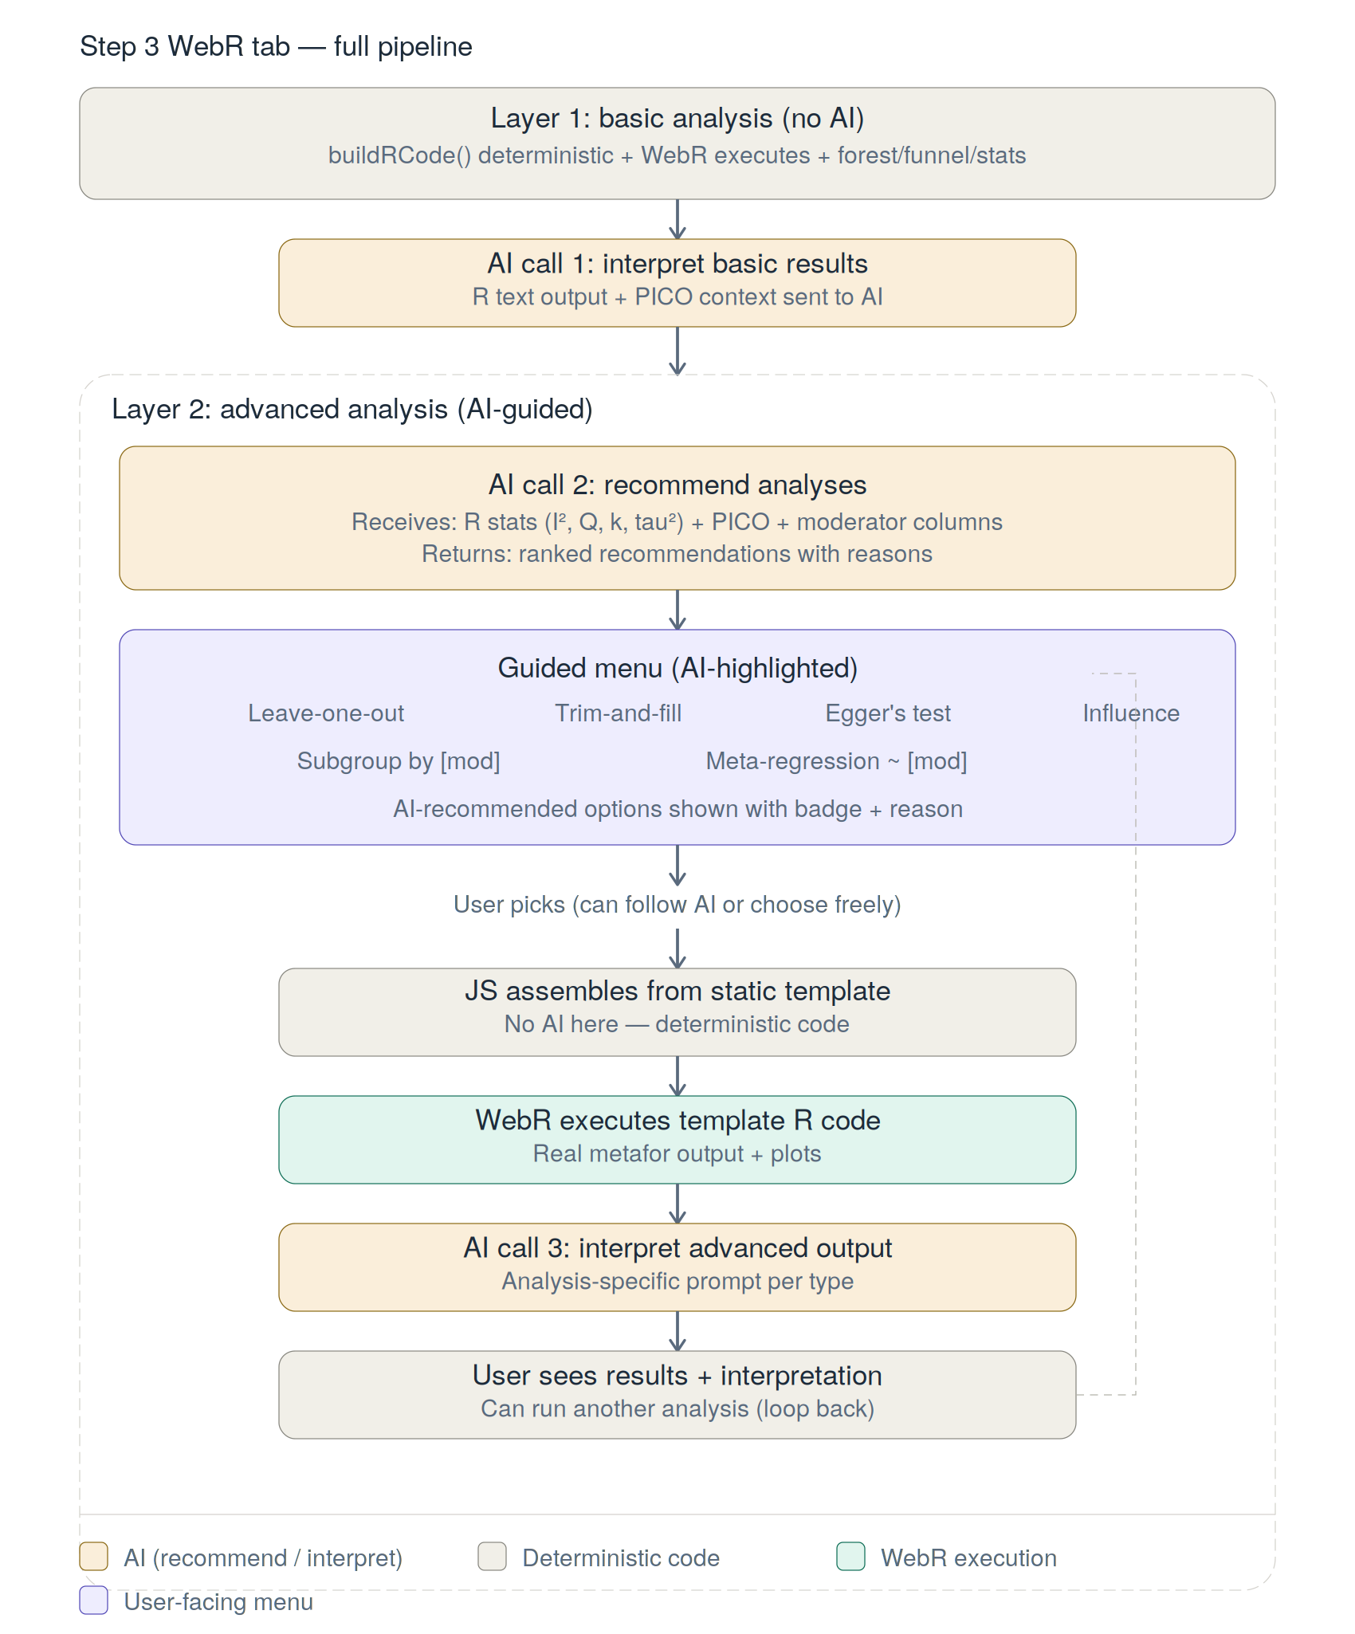
Figure 2 — The complete Layer 2 pipeline: AI recommends, user picks, JS assembles templates, WebR executes, AI interprets.
Role 1 — Recommend (AI Call 2): AI receives the Layer 1 R output (I², Q, k, τ²) + PICO context + available moderator columns. It returns ranked recommendations with reasons, e.g.: “Your I² is 35% with 5 studies — I recommend leave-one-out to check robustness, and subgroup by Population Focus since your studies mix CKD-specific and high-CV-risk populations.” These appear as highlighted options in the guided menu.
Role 2 — Never touch code: The user picks from the menu (AI-highlighted or freely chosen). JS validates against a whitelist and slots parameters into pre-written, pre-tested R template blocks. AI is not involved in code assembly.
Analysis type | R template | Needs moderator?
Leave-one-out | leave1out(res) | No
Trim-and-fill | trimfill(res); funnel(tf) | No
Egger’s regression | regtest(res) | No
Influence diagnostics | influence(res); plot(inf) | No
Subgroup analysis | rma() per subgroup level | Yes (categorical)
Meta-regression | rma(mods=~moderator) | Yes

Role 3 — Interpret advanced output (AI Call 3): After WebR executes the template code, AI reads the new R output and provides analysis-specific interpretation. The user can then run another analysis, looping back to the menu.

5. The safety firewall — what AI does vs. does not touch
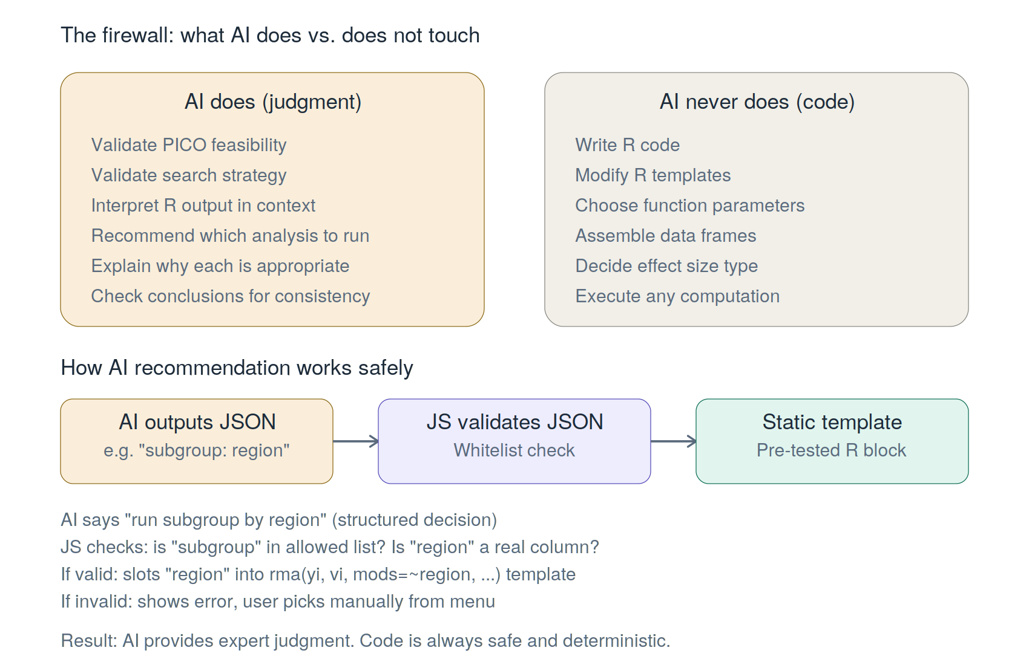
Figure 3 — The AI/code firewall: AI provides judgment, JS provides safe execution.
How the recommendation step stays safe: AI outputs a structured decision (e.g. “subgroup analysis by Region”). JavaScript validates: Is “subgroup” an allowed type? Is “Region” an actual column? If valid, JS slots it into the pre-tested template. If invalid, fallback to the manual menu. AI never sees or modifies any R code.

6. Complete AI call inventory
# | Checkpoint | Location | Trigger
1 | PICO validation | Midterm Step 1 | User clicks AI Check
2 | Search strategy check | Midterm Step 2 | User clicks AI Check
3 | Interpret basic results | Final Step 3 (Layer 1) | User clicks AI Interpret
4 | Recommend analyses | Final Step 3 (Layer 2) | Automatic after Layer 1
5 | Interpret advanced output | Final Step 3 (Layer 2) | User runs advanced analysis
6 | Check conclusions | Final Step 5 | User clicks AI Check

Most users hit 4 calls per full workshop run. Estimated cost: ~$0.01–0.03 per run. All calls gated behind login + course completion.

7. Why this design matters
 | Other MA websites | Meta-Analysis 101
Basic analysis | User inputs data, static code runs | Same — deterministic R via WebR
Advanced | User must know what to run | AI evaluates results, recommends what and why
Interpretation | User reads raw output alone | AI provides PICO-aware interpretation
Code safety | N/A (fixed scripts) | AI never writes code — JS uses templates
Teaching | Computation tool only | Guided methodology + computation + AI feedback

In summary: AI acts as a methodology advisor — it looks at the user’s specific results and tells them what to explore next and why. All code generation remains deterministic. Same inputs = same R code = same results. AI provides expert judgment; JavaScript provides reliable execution.

8. Technology stack
Layer | Technology | Role
Frontend | React (inline styles) | UI, wizard flow, state management
In-browser R | WebR (WASM) + metafor | Real R execution, forest/funnel plots
AI proxy | Vercel serverless + Anthropic API | AI feedback calls (key hidden server-side)
Backend | Supabase (PostgreSQL) | Auth, progress tracking, AI gating
Hosting | Vercel | Deployment, preview branches
Bilingual | Custom useI18n() hook | Traditional Chinese / English

